# COAL LAB 4

Q.1) Carry flag = 0 and Sign flag = 0

Include Irvine32.inc

.data

val1 sdword 8000d

.code

main PROC

mov eax,val1

add eax,1

mov edx,eax

call writeint

call dumpregs

exit

main ENDP

END main

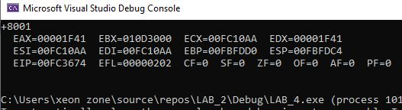

Q.2)

Include Irvine32.inc

.code

main PROC

mov eax,0

mov ax,7FF0h

add al,10h

add ah,1

add ax,2

call dumpregs

exit

main ENDP

END main

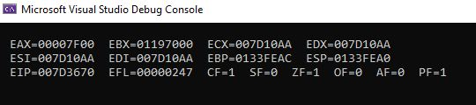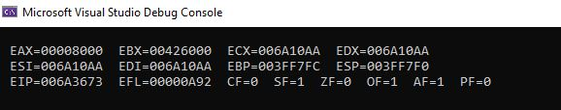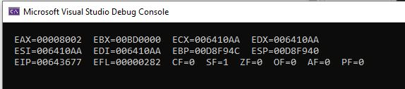

Q.3)

Include Irvine32.inc

.data

array dword 8,5,1,2,6

.code

main PROC

mov eax,0

mov edx,0

mov esi,offset array

mov eax,[esi]

xchg [esi+16],eax

xchg eax,[esi+12]

xchg eax,[esi+4]

xchg eax,[esi+8]

xchg eax,[esi]

mov ecx,lengthof array

l1:

mov eax,[esi]

add esi,4

call writeint

call crlf

loop l1

call dumpregs

exit

main ENDP

END main

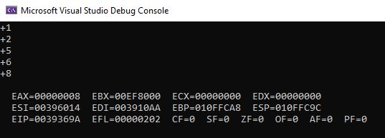

Q.4)

INCLUDE Irvine32.inc

.data

arrayB BYTE 10, 20, 30

arrayW WORD 150, 250, 350

arrayD DWORD 600, 1200, 1800

SUM1 DWORD ?

SUM2 DWORD ?

SUM3 DWORD ?

.code

main PROC

mov eax,0

mov esi,0

mov al,arrayB[esi]

add ax,arrayW[esi]

add eax,arrayD[esi]

call writedec

call crlf

mov eax,0

inc esi

mov al,arrayB[esi]

add ax,arrayW[esi*TYPE arrayW]

add eax,arrayD[esi*TYPE arrayD]

call writedec

call crlf

mov eax,0

inc esi

mov al,arrayB[esi]

add ax,arrayW[esi*TYPE arrayW]

add eax,arrayD[esi*TYPE arrayD]

call writedec

call crlf

exit

main ENDP

END main

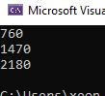

Q.5)

INCLUDE Irvine32.inc

.data

array1 BYTE 10, 20, 30, 40

array2 BYTE 4 DUP (?)

.code

main PROC

mov esi,0

mov ecx,4

L1:

mov eax,0

mov al,array1[esi]

sub ecx,1

mov array2[ecx],al

add esi,1

add ecx,1

loop L1

mov esi,0

mov ecx,4

l:

mov eax,0

mov al,array2[esi]

call writedec

call crlf

inc esi

loop l

exit

main ENDP

END main

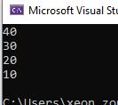

Q.6)

INCLUDE Irvine32.inc

.data

array BYTE 2, 4, 6, 8

.code

main PROC

mov esi,0

mov esi,offset array

mov ecx,4

l:

mov eax,0

mov al,[esi]

sub al,1

call writedec

call crlf

inc esi

loop l

exit

main ENDP

END main

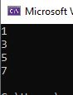

Q.7)

INCLUDE Irvine32.inc

.data

arrayB BYTE 60, 70, 80

arrayW WORD 150, 250, 350

arrayD DWORD 600, 1200, 1800

.code

main PROC

mov esi,0

mov eax,0

mov ebx,0

mov edx,0

mov al,arrayB[esi*TYPE arrayB]

inc esi

add al,arrayB[esi*TYPE arrayB]

call writedec

call crlf

mov edx,eax

mov esi,0

mov eax,0

mov ebx,0

mov ax,arrayW[esi*TYPE arrayW]

inc esi

add ax,arrayW[esi*TYPE arrayW]

call writedec

call crlf

mov ebx,eax

mov esi,0

mov eax,0

mov ecx,0

mov eax,arrayD[esi*TYPE arrayD]

inc esi

add eax,arrayD[esi*TYPE arrayD]

call writedec

call crlf

call dumpregs

exit

main ENDP

END main

